VENDREDI 7 SEPTEMBRE 金曜日9月7日

VOL
Départ Paris CDG 2 TERMINAL C 11:45
Le terminal 2C se trouve juste à côté de la gare TVG/RER (pas besoin de prendre la navette)
Arrivée MOSCOU SHEREMETYEVO TERMINAL 2 17:15
AEROFLOT n°SU250 - AIRBUS A320
01.42.25.31.92

SAMEDI 8 SEPTEMBRE 土曜日9月8日

VOL
Départ MOSCOU SHEREMETYEVO TERMINAL 2 19 :20
Arrivée TOKYO NARITA TERMINAL 2 10 :00
AEROFLOT n°SU581 – BOEING 767

AEROPORT NARITA
Récupération Japan Rail Pass au centre de services de voyage de la gare

TRAJET AEROPORT – TOKYO
NEX (JR Narita Express) obligation de réserver un ticket
Réservation des billets Shinkansen pour le 9 sept ?
11h19→12h12 (NEX14)
12h19→13h12 (NEX16)
13h19→14h12 (NEX18)
13h46→14h41 (NEX20)
14h16→15h16 (NEX22)
14h46→15h43 (NEX24)

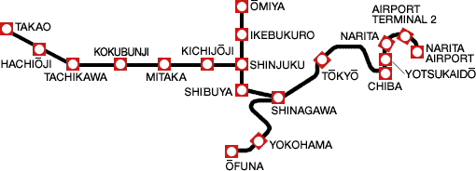
TOKYO 東京

TRAJET TOKYO – AUBERGE DE JEUNESSE
A Tokyo Station
Yamanote Line jusqu’à Ueno (10 min)
(ligne Yamanote 山手線)
A Ueno Station
Hibiya Line (ou JR Joban Line) jusqu’à Minamisenju

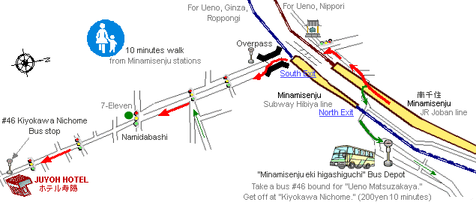

from Minamisenju on JR Joban line: 10 minutes walk.
There is only one exit. Walk the path along the rail track upto the intersection of Ekoin temple. Turn to left. You will see the South Exit of Minamisenju on Hibiya line. Cross the overpass. Walk straight along the main street.

AUBERGE DE JEUNESSE
JUYOH HOTEL
http://www.juyoh.co.jp/document/english/english.html
3000 Y

Laisser le(s) sac(s) pour l’ascension du mont Fuji à l’accueil
Réserver pour les nuits de retour à Tokyo

Pour les autres auberges, voir celles indiquées dans le Lonely Planet

VISITES TOKYO

Voir pour les possibilités de réservation des bus pour le mont fuji
Ueno ? (LP p103 – NG p92)
Centre de Tokyo ? (LP p101 - NG p63)

DIMANCHE 9 SEPTEMBRE 日曜日9月9日

TRAJET AUBERGE DE JEUNESSE – GARE
A Minamisenju Station
Hibiya Line (ou JR Joban Line) jusqu’à Ueno

TRAJET UENO – NIKKO
UENO | UTSUNOMIYA |  | NIKKO
Platform 20 |  | Platform 5
8h14 | 8h58 |  |  | SHINKANSEN MaxYAMABIKO 105 / TSUBASA 105
 |  | 9h12 | 9h54 | JR Nikko Line
8h26 | 9h13 |  |  | SHINKANSEN YAMABIKO 45
8h42 | 9h30 |  |  | SHINKANSEN NASUNO 251
9h06 | 9h50 |  |  | SHINKANSEN MaxYAMABIKO 107 / TSUBASA 107
 |  | 9h57 | 10h52 | JR Nikko Line
9h38 | 10h23 |  |  | SHINKANSEN YAMABIKO 47
 |  | 10h35 | 11h17 | JR Nikko Line
9h46 | 10h35 |  |  | SHINKANSEN NASUNO 253
10h14 | 10h58 |  |  | SHINKANSEN MaxYAMABIKO 111 / TSUBASA 111
 |  | 11h40 | 12h21 | JR Nikko Line

UENO Leave - UTSUNOMIYA Arrive (09/09/2007)
Train name | UENO | OMIYA | OYAMA | UTSUNOMIYA
SHINKANSEN YAMABIKO 205 | 07:46 | 08:06 | 08:23 | 08:34
SHINKANSEN MaxYAMABIKO 105 | 08:14 | 08:34 | -> | 08:58
SHINKANSEN TSUBASA 105 | 08:14 | 08:34 | -> | 08:58
*SHINKANSEN YAMABIKO 45 | 08:26 | 08:46 | -> | 09:13
SHINKANSEN NASUNO 251 | 08:42 | 09:02 | 09:19 | 09:30
*SHINKANSEN MaxYAMABIKO 107 | 09:06 | 09:26 | -> | 09:50
*SHINKANSEN TSUBASA 107 | 09:06 | 09:26 | -> | 09:50
SHINKANSEN YAMABIKO 47 | 09:38 | 09:58 | -> | 10:23
SHINKANSEN NASUNO 253 | 09:46 | 10:06 | 10:24 | 10:35
SHINKANSEN MaxYAMABIKO 111 | 10:14 | 10:34 | -> | 10:58
SHINKANSEN TSUBASA 111 | 10:14 | 10:34 | -> | 10:58
SHINKANSEN MaxYAMABIKO 207 | 10:26 | 10:46 | 11:03 | 11:14

Possibilité de prendre le train à son terminus de départ (Tokyo Station). Dans ce cas, retirer 6 minutes sur les horaires de Ueno.

UTSUNOMIYA Leave - NIKKO Arrive (09/09/2007)
Train name | UTSUNOMIYA | TSURUTA | KANUMA | FUBASAMI | SHIMOTSUKEOSAWA | IMAICHI | NIKKO
JR Nikko Line | 09:12 | 09:18 | 09:27 | 09:34 | 09:40 | 09:46 | 09:54
JR Nikko Line | 09:57 | 10:04 | 10:13 | 10:22 | 10:28 | 10:34 | 10:42
JR Nikko Line | 10:35 | 10:41 | 10:50 | 10:58 | 11:04 | 11:10 | 11:17
JR Nikko Line | 11:40 | 11:45 | 11:54 | 12:02 | 12:08 | 12:13 | 12:21
JR Nikko Line | 12:38 | 12:43 | 12:53 | 13:00 | 13:06 | 13:12 | 13:20
JR Nikko Line | 13:32 | 13:38 | 13:47 | 13:55 | 14:01 | 14:07 | 14:14
JR Nikko Line | 14:32 | 14:37 | 14:46 | 14:54 | 15:00 | 15:06 | 15:13

NIKKO 日光

Consignes à la gare JR de Nikko ?

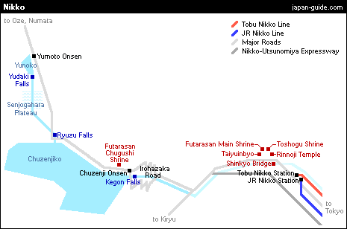

VISITES NIKKO
LP p166 – NG p114

Pont Shin-kyo
Ticket groupé pour le Rinno-Ji, le Tosho-gu, Futaarasan et Taiyuin-Byo

A 10 kms à l’Ouest de Nikko, lac de Chuzenji-ko et cascade de Kegon-no-taki >> beaux paysages
Accessible en 50 min par bus depuis la gare JR (arrêt n°2) jusqu’à Chuzenji Onsen

TRAJET NIKKO – SENDAI

NIKKO | UTSUNOMIYA |  | SENDAI
 | Platform 5 | Platform 1
17h08 | 17h49 |  |  | JR Nikko Line
 |  | 17h59 | 19h20 | SHINKANSEN MaxYAMABIKO 125
17h35 | 18h17 |  |  | JR Nikko Line
 |  | 18h19 | 19h49 | SHINKANSEN YAMABIKO 215
 |  | 18h26 | 19h32 | SHINKANSEN YAMABIKO 63
 |  | 18h59 | 20h20 | SHINKANSEN MaxYAMABIKO 127
18h21 | 19h02 |  |  | JR Nikko Line
 |  | 19h17 | 20h47 | SHINKANSEN YAMABIKO 217
19h03 | 19h47 |  |  | JR Nikko Line
 |  | 19h51 | 20h58 | SHINKANSEN YAMABIKO 65
 |  | 20h07 | 21h31 | SHINKANSEN MaxYAMABIKO 129

NIKKO Leave - UTSUNOMIYA Arrive (9/9/2007)
Train name | NIKKO | IMAICHI | SHIMOTSUKEOSAWA | FUBASAMI | KANUMA | TSURUTA | UTSUNOMIYA
JR Nikko Line | 16:00 | 16:07 | 16:13 | 16:20 | 16:29 | 16:40 | 16:45
JR Nikko Line | 16:43 | 16:50 | 16:56 | 17:03 | 17:11 | 17:20 | 17:26
JR Nikko Line | 17:08 | 17:15 | 17:21 | 17:27 | 17:34 | 17:44 | 17:49
JR Nikko Line | 17:35 | 17:42 | 17:49 | 17:55 | 18:02 | 18:11 | 18:17
JR Nikko Line | 18:21 | 18:28 | 18:34 | 18:40 | 18:48 | 18:57 | 19:02
JR Nikko Line | 19:03 | 19:11 | 19:17 | 19:24 | 19:33 | 19:42 | 19:47
JR Nikko Line | 19:35 | 19:42 | 19:49 | 19:55 | 20:03 | 20:14 | 20:19

UTSUNOMIYA Leave - SENDAI Arrive (9/9/2007)
Train name | UTSUNOMIYA | NASUSHIOBARA | KORIYAMA | FUKUSHIMA | SHIROISHIZAO | SENDAI
SHINKANSEN MaxYAMABIKO 123 | 16:58 | -> | 17:31 | 17:52 | 18:05 | 18:20
SHINKANSEN YAMABIKO 213 | 17:19 | 17:40 | 18:10 | 18:26 | -> | 18:49
SHINKANSEN YAMABIKO 61 | 17:26 | -> | 17:56 | 18:11 | -> | 18:32
*LTD.EXP CASSIOPEIA | 17:50 | -> | 19:13 | 19:52 | -> | 20:57
*SHINKANSEN MaxYAMABIKO 191 | 17:52 | -> | -> | 18:39 | -> | 19:03
SHINKANSEN MaxYAMABIKO 125 | 17:59 | -> | 18:32 | 18:52 | 19:05 | 19:20
LTD.EXP HOKUTOSEI 1 | 18:12 | -> | 19:34 | 20:10 | -> | 21:12
SHINKANSEN YAMABIKO 215 | 18:19 | 18:40 | 19:10 | 19:26 | -> | 19:49
SHINKANSEN YAMABIKO 63 | 18:26 | -> | 18:56 | 19:11 | -> | 19:32
SHINKANSEN MaxYAMABIKO 127 | 18:59 | -> | 19:32 | 19:52 | 20:05 | 20:20
SHINKANSEN YAMABIKO 217 | 19:17 | 19:32 | 19:59 | 20:19 | 20:32 | 20:47
SHINKANSEN YAMABIKO 65 | 19:51 | -> | 20:21 | 20:36 | -> | 20:58
SHINKANSEN MaxYAMABIKO 129 | 20:07 | -> | 20:43 | 21:02 | 21:15 | 21:31
SHINKANSEN YAMABIKO 219 | 20:19 | 20:40 | 21:05 | 21:25 | -> | 21:49
LTD.EXP HOKUTOSEI 3 | 20:29 | -> | 21:53 | 22:29 | -> | 23:28
SHINKANSEN MaxYAMABIKO 221 | 20:35 | 20:52 | 21:22 | 21:38 | 21:51 | 22:07

SENDAI 仙台
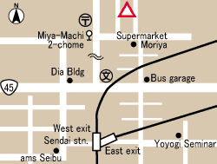
AUBERGES DE JEUNESSE (2 nuits) LP p479

CHITOSE YOUTH HOSTEL
http://www.jyh.or.jp/english/touhoku/sendai/index.html
3700 yens (650 yens petit déj)
Access: From JR Sendai station, take No.17 or 19 bus, and get off at miyamachi 2-chome, and walk for 3 minutes
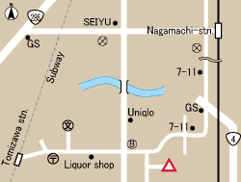
DOCHU –AN YOUTH HOSTEL
http://www.jyh.or.jp/english/touhoku/dochuan/index.html
3700 yens (630 yens petit déj)
Access: From subway Tomizawa station, walk for 20 minutes. or From JR Nagamachi station, walk for 20 minutes.
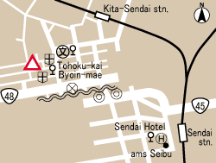
A 5 kms au sud de Sendai

MAPLE SENDAI
http://www.jyh.or.jp/english/touhoku/maple/index.html
3300 yens (420 yens petit déj)
Access: From JR Sendai station, and take No.25 bus for 15 minutes, and get off at Tohoku-byoin, and walk for 2 minutes.

TAKENAKA RYOKAN
4200 yens

LUNDI 10 SEPTEMBRE 月曜日9月10日

VISITES SENDAI LP p477 – NG p161
Zuiho-den, Sendai-jo

TRAJET SENDAI – MATSUSHIMA

Réserver les billets de Shinkansen pour le 11 septembre

SENDAI | MATSUSHIMAKAIGAN
10h08 | 10h34 | JR Senseki Line
10h18 | 10h57 | JR Senseki Line
11h07 | 11h33 | JR Senseki Line
11h18 | 11h56 | JR Senseki Line
12h07 | 12h33 | JR Senseki Line
12h18 | 12h56 | JR Senseki Line
12h58 | 13h33 | JR Senseki Line
13h20 | 13h56 | JR Senseki Line

Stations : SENDAI → TSUTSUJIGAOKA → MIYAGINOHARA → RIKUZENHARANOMACHI → NIGATAKE → KOZURUSHINDEN → FUKUDAMACHI → RIKUZENTAKASAGO → NAKANOSAKAE → TAGAJO → GEBA → NISHISHIOGAMA → HONSHIOGAMA → HIGASHISHIOGAMA → RIKUZENHAMADA → MATSUSHIMAKAIGAN

A popular way to visit the region, is to take the JR Senseki Line from Sendai to Hon-Shiogama Station, take a boat ride across Matsushima Bay to Matsushima, sightsee in Matsushima, and then return to Sendai by Senseki Line.
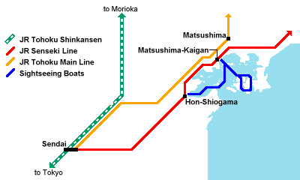

MATSHUSHIMA松島
VISITES MATSUSHIMA LP p483 – NG p162
Zuigan-ji, Godai-do, île Fukura-jima

TRAJET MATSUSHIMA – OKU-MATSUSHIMA
MATSUSHIMAKAIGAN | NOBIRU
13h34 | 13h45 | JR Senseki Line
13h57 | 14h14 | JR Senseki Line
14h34 | 14h45 | JR Senseki Line
14h57 | 15h14 | JR Senseki Line
15h34 | 15h45 | JR Senseki Line
15h57 | 16h15 | JR Senseki Line
16h34 | 16h45 | JR Senseki Line
16h57 | 17h15 | JR Senseki Line

MATSUSHIMAKAIGAN Leave - NOBIRU Arrive (10/09/2007)
Train name | MATSUSHIMAKAIGAN | TAKAGIMACHI | TETARU | RIKUZENTOMIYAMA | RIKUZENOTSUKA | TONA | NOBIRU
JR Senseki Line | 13:34 | 13:37 | -> | -> | -> | -> | 13:45
JR Senseki Line | 13:57 | 14:01 | 14:04 | 14:06 | 14:09 | 14:12 | 14:14
JR Senseki Line | 14:34 | 14:37 | -> | -> | -> | -> | 14:45
JR Senseki Line | 14:57 | 15:01 | 15:04 | 15:06 | 15:09 | 15:12 | 15:14
JR Senseki Line | 15:34 | 15:37 | -> | -> | -> | -> | 15:45
JR Senseki Line | 15:57 | 16:01 | 16:04 | 16:06 | 16:09 | 16:12 | 16:15
JR Senseki Line | 16:34 | 16:37 | -> | -> | -> | -> | 16:45
JR Senseki Line | 16:57 | 17:01 | 17:04 | 17:06 | 17:09 | 17:12 | 17:15

VISITES OKU-MATSUSHIMA
Sagakei, falaise de 40m de haut
Colline Otakamori : panorama exceptionnel
Plage de Nobiru
Excursions en bateau autour des îles
Location de vélos à la gare

TRAJET OKU-MATSUSHIMA – SENDAI

NOBIRU | SENDAI
17h17 | 18h08 | JR Senseki Line
17h46 | 18h39 | JR Senseki Line
18h19 | 18h57 | JR Senseki Line
18h46 | 19h42 | JR Senseki Line
19h28 | 20h04 | JR Senseki Line
19h54 | 20h48 | JR Senseki Line
20h31 | 21h06 | JR Senseki Line
21h23 | 22h18 | JR Senseki Line

Stations identiques qu’à l’aller en sens inverse
MARDI 11 SEPTEMBRE 火曜日9月11日

TRAJET SENDAI – HAKODATE
SENDAI | HACHINOHE |  | HAKODATE
Platform 11 ou 12
8h38 | 10h03 |  |  | SHINKANSEN HAYATE 1
 |  | 10h15 | 13h14 | LTD.EXP SUPER HAKUCHO 1
9h19 | 10h39 |  |  | SHINKANSEN HAYATE 3
 |  | 10h50 | 13h58 | LTD.EXP HAKUCHO 3
10h13 | 11h31 |  |  | SHINKANSEN HAYATE 7
10h38 | 12h03 |  |  | SHINKANSEN HAYATE 9
 |  | 12h16 | 15h12 | LTD.EXP SUPER HAKUCHO 9
 |  | 14h15 | 17h33 | LTD.EXP HAKUCHO 15

SENDAI Leave - HACHINOHE Arrive (11/09/2007)
Train name | SENDAI | MORIOKA | IWATENUMAKUNAI | NINOHE | HACHINOHE
SHINKANSEN HAYATE 1 | 08:38 | 09:26 | 09:39 | 09:52 | 10:03
SHINKANSEN HAYATE 3 | 09:19 | 10:06 | -> | 10:28 | 10:39
SHINKANSEN HAYATE 7 | 10:13 | 11:03 | -> | -> | 11:31
SHINKANSEN HAYATE 9 | 10:38 | 11:26 | 11:39 | 11:52 | 12:03

HACHINOHE Leave - HAKODATE Arrive (11/09/2007)
Train name | HACHINOHE | MISAWA | NOHEJI | AOMORI | KANITA | KIKONAI | HAKODATE
LTD.EXP SUPER HAKUCHO 1 | 10:15 | 10:28 | 10:45 | 11:19 | 11:43 | 12:31 | 13:14
LTD.EXP HAKUCHO 3 | 10:50 | 11:04 | 11:22 | 11:56 | -> | -> | 13:58
LTD.EXP SUPER HAKUCHO 9 | 12:16 | 12:29 | 12:46 | 13:21 | 13:46 | 14:36 | 15:12
LTD.EXP HAKUCHO 15 | 14:15 | 14:29 | 14:47 | 15:22 | 15:53 | 16:48 | 17:33

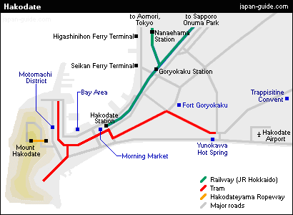

HAKODATE函館
VISITES HAKODATE
Consignes gare Hakodate ?
(LP p549 – NG p138)
Quartier de Motomachi : beaux monuments, beaux panoramas sur la baie, temples boudhiques, cimetière des étrangers, bateax de pêche aux calamars
Mont Hakodate (334m) : point de vue sur la ville incroyable (funiculaire AR 1160 yens)
Hakodateyama Yosai (fort oublié)
Goyo-Kaku (fort japonais de style occidental)

Promenade à Hakodate détaillée dans NG p 140/141

TRAJET HAKODATE – TOYA

HAKODATE | TOYA
13h29 | 15h11 | LTD.EXP HOKUTO 11
14h13 | 15h47 | LTD.EXP SUPER HOKUTO 13
15h23 | 17h08 | LTD.EXP HOKUTO 15
17h55 | 19h39 | LTD.EXP HOKUTO 19
19h42 | 21h15 | LTD.EXP SUPER HOKUTO 21

HAKODATE Leave - TOYA Arrive (11/09/2007)
Train name | HAKODATE | ONUMAKOEN | MORI | YAKUMO | OSHAMAMBE | TOYA
LTD.EXP HOKUTO 11 | 13:29 | 13:49 | 14:07 | 14:28 | 14:47 | 15:11
LTD.EXP SUPER HOKUTO 13 | 14:13 | 14:30 | 14:49 | 15:07 | 15:26 | 15:47
LTD.EXP HOKUTO 15 | 15:23 | 15:43 | 16:01 | 16:22 | 16:43 | 17:08
LTD.EXP HOKUTO 19 | 17:55 | -> | 18:33 | 18:53 | 19:13 | 19:39
LTD.EXP SUPER HOKUTO 21 | 19:42 | -> | 20:16 | 20:35 | 20:53 | 21:15

From Toya Station, buses depart for Lake Toya about once per hour, taking less than 20 minutes. They are operated by Donan Bus.

AUBERGE DE JEUNESSE
showa-shinzan youth hostel
http://www.youthhostel.or.jp/English/s_syowashinzan.htm
(3150 yens)
Access : Take train to JR Toya Station and transfer to the bus bound for Toya-Onsen. Get off at the last stop (15 min.) and transfer to either the bus bound for Showa-shinzan or the bus bound for Muroran via Soubetsu. Get off at "Tozan-Guchi." (8 min.) from which it is a one minute walk
Location de vélos possible pour 1000 yens)jour

TOYA GREEN HOTEL
5300-7400 yens par personne (2 repas compris)
MERCREDI 12 SEPTEMBRE 水曜日9月12日
LAC TOYA洞爺湖
(LP p559 - NG p 135)
Volcan Showa-Shin-zan (407m) funiculaire jusqu’au sommet pour admirer le spectacle impressionnant de ses entrailles infernales ou le Yotei-San
Volcan Usu-zan : très actif, chemins tortueux parmi les bâtiments détruits par les cendres. Téléphérique jusqu’au sommet (1450 yens)
Promenade du cratère Nishiyama (gratuit)
Musée scientifique des volcans (600 yens) : passionnant documentaire sur l’éruption de 1977
Normalement feu d’artifice sur le lac le soir à 20h45

JEUDI 13 SEPTEMBRE 木曜日9月13日

TRAJET TOYA – TOKYO – KAMAKURA/YOKOHAMA

TOYA | HAKODATE |  | HACHINOHE |  | TOKYO
9h24 | 11h11 |  |  |  |  | LTD.EXP HOKUTO 4
 |  | 11h28 | 14h45 |  |  | LTD.EXP HAKUCHO 20
 |  |  |  | 14h56 | 18h08 | SHINKANSEN HAYATE 20
10h16 | 11h53 |  |  |  |  | LTD.EXP SUPER HOKUTO 6
11h04 | 12h49 |  |  |  |  | LTD.EXP HOKUTO 8
 |  | 12h53 | 15h50 |  |  | LTD.EXP SUPER HAKUCHO 24
 |  |  |  | 16h05 | 19h08 | SHINKANSEN HAYATE 24
 |  | 13h54 | 16h45 |  |  | LTD.EXP SUPER HAKUCHO 28
 |  |  |  | 16h56 | 20h08 | SHINKANSEN HAYATE 28

TOYA Leave - HAKODATE Arrive (13/09/2007)
Train name | TOYA | OSHAMAMBE | YAKUMO | MORI | ONUMAKOEN | GORYOKAKU | HAKODATE
LTD.EXP HOKUTO 4 | 09:24 | -> | 10:11 | -> | 10:49 | -> | 11:11
LTD.EXP SUPER HOKUTO 6 | 10:16 | 10:39 | 10:57 | 11:15 | 11:33 | -> | 11:53
LTD.EXP HOKUTO 8 | 11:04 | 11:30 | 11:49 | 12:10 | 12:27 | -> | 12:49
LTD.EXP SUPER HOKUTO 10 | 12:15 | 12:39 | 12:56 | -> | 13:29 | -> | 13:50

HAKODATE Leave - HACHINOHE Arrive (13/09/2007)
Train name | HAKODATE | KIKONAI | KANITA | AOMORI | NOHEJI | MISAWA | HACHINOHE
LTD.EXP HAKUCHO 18 | 10:40 | 11:19 | -> | 12:49 | 13:18 | 13:36 | 13:52
LTD.EXP HAKUCHO 20 | 11:28 | 12:08 | 13:07 | 13:43 | 14:12 | 14:30 | 14:45
*LTD.EXP SUPER HAKUCHO 24 | 12:53 | 13:31 | -> | 14:51 | 15:20 | 15:37 | 15:50
LTD.EXP SUPER HAKUCHO 28 | 13:54 | 14:31 | 15:18 | 15:47 | 16:14 | 16:31 | 16:45
LTD.EXP SUPER HAKUCHO 32 | 15:42 | 16:19 | 17:10 | 17:43 | 18:10 | 18:27 | 18:40

HACHINOHE Leave - TOKYO Arrive (13/09/2007)
Train name | HACHINOHE | NINOHE | MORIOKA | SENDAI | OMIYA | UENO | TOKYO
SHINKANSEN HAYATE 18 | 14:04 | -> | 14:40 | 15:26 | 16:43 | 17:03 | 17:08
SHINKANSEN HAYATE 20 | 14:56 | 15:08 | 15:40 | 16:26 | 17:43 | 18:03 | 18:08
*SHINKANSEN HAYATE 24 | 16:05 | -> | 16:40 | 17:26 | 18:43 | 19:03 | 19:08
SHINKANSEN HAYATE 28 | 16:56 | 17:08 | 17:40 | 18:26 | 19:43 | 20:03 | 20:08
*SHINKANSEN HAYATE 30 | 18:00 | 18:12 | 18:40 | 19:26 | 20:43 | 21:03 | 21:08

TOKYO | YOKOHAMA
18h25 | 19h22 | JR Rapid Airport Narita
18h38 | 19h33 | JR Yokosuka Line
18h43 | 19h39 | JR Yokosuka Line
18h54 | 19h52 | JR Yokosuka Line
19h04 | 20h01 | JR Yokosuka Line
19h14 | 20h10 | JR Yokosuka Line
19h24 | 20h18 | JR Rapid Airport Narita
AUBERGE DE JEUNESSE
KAMAKURA KAGETSUEN YOUTH HOSTEL
(dortoir 3308 yens)
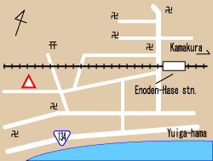
Accès : Depuis la gare de Kamakura, prendre la ligne Enoden Enoshima jusqu’à la gare de Hase. Tourner à gauche à la sortie de la gare, rejoindre le front de mer, tourner à droite et marcher environ 10 min en direction de l’ouest. L’auberge est dans le Kagetsuen Hotel

KAMAKURA HASE
http://www.jyh.or.jp/english/kanto/hase/index.html
(3960 yens) 5-11 Sakanoshita, Kamakura-sho, Kanagawa
Access: From Enoden Hase station, walk for 3 minute.

VENDREDI 14 SEPTEMBRE 金曜日9月14日

KAMAKURA鎌倉

VISITES KAMAKURA
(LP p200 – NG p111)
Temple Engaku-ji
Temple Tokei-ji
Daibutsu : boudha en statue de bronze de 850 tonnes

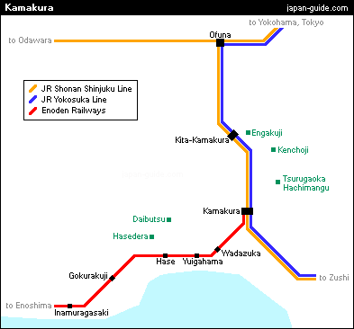

TRAJET KAMAKURA – YOKOHAMA
Ligne JR Yokosuka Line toutes les 5/10 minutes

VISITES YOKOHAMA
Chinatown (le plus grand du Japon)

YOKOHAMA横浜

TRAJET YOKOHAMA – MATSUMOTO
2 options :
Ligne JR ShonanShinjuku Line toutes les 10 à 30 minutes pour rejoindre Shinjuku
Puis LTD.EXP AZUSA 17 de Shinjuku à Matsumoto toutes les heures (2h30)

YOKOHAMA Leave - SHINJUKU Arrive (14/09/2007)
Train name | YOKOHAMA | SHINKAWASAKI | NISHIOI | OSAKI | EBISU | SHIBUYA | SHINJUKU
JR ShonanShinjuku Line | 10:44 | -> | -> | 11:01 | -> | 11:06 | 11:11
JR ShonanShinjuku Line | 10:56 | 11:05 | 11:12 | 11:16 | 11:20 | 11:22 | 11:27
JR ShonanShinjuku Line | 11:14 | -> | -> | 11:33 | 11:38 | 11:40 | 11:45
JR ShonanShinjuku Line | 11:25 | 11:34 | 11:41 | 11:45 | 11:50 | 11:52 | 11:57
JR ShonanShinjuku Line | 11:44 | -> | -> | 12:01 | -> | 12:06 | 12:11
JR ShonanShinjuku Line | 11:56 | 12:05 | 12:12 | 12:16 | 12:20 | 12:22 | 12:27
JR ShonanShinjuku Line | 12:14 | -> | -> | 12:33 | 12:38 | 12:40 | 12:45
JR ShonanShinjuku Line | 12:25 | 12:34 | 12:41 | 12:45 | 12:50 | 12:52 | 12:57
JR ShonanShinjuku Line | 12:44 | -> | -> | 13:01 | -> | 13:06 | 13:11
JR ShonanShinjuku Line | 12:56 | 13:05 | 13:12 | 13:16 | 13:20 | 13:22 | 13:27
JR ShonanShinjuku Line | 13:14 | -> | -> | 13:33 | 13:38 | 13:40 | 13:45
JR ShonanShinjuku Line | 13:25 | 13:34 | 13:41 | 13:45 | 13:50 | 13:52 | 13:57

SHINJUKU Leave - MATSUMOTO Arrive (14/09/2007)
Train name | SHINJUKU | HACHIOJI | KOFU | CHINO | KAMISUWA | SHIOJIRI | MATSUMOTO
LTD.EXP SUPER AZUSA 15 | 11:00 | 11:31 | 12:31 | 13:08 | 13:13 | 13:27 | 13:36
*LTD.EXP AZUSA 17 | 12:00 | 12:32 | 13:33 | 14:13 | 14:20 | 14:36 | 14:45
LTD.EXP AZUSA 19 | 13:00 | 13:32 | 14:32 | 15:15 | 15:21 | 15:37 | 15:46
LTD.EXP SUPER AZUSA 21 | 14:00 | 14:29 | 15:24 | 16:00 | 16:05 | -> | 16:26

Ou
Ligne JR Yokosuka Line toutes les 5/10 minutes jusqu’à Tokyo
Shinkansen Tokyo Nagano (1h40)
LTD.EXP (WIDEVIEW)SHINANO Nagano à Matsumoto (environ 50 mn)

TOKYO Leave - NAGANO Arrive (14/09/2007)
Train name | TOKYO | UENO | OMIYA | TAKASAKI | KARUIZAWA | SAKUDAIRA | UEDA | NAGANO
SHINKANSEN ASAMA 521 | 11:44 | 11:50 | 12:10 | 12:38 | 12:55 | 13:04 | 13:15 | 13:27
SHINKANSEN ASAMA 523 | 12:24 | 12:30 | 12:50 | 13:15 | 13:37 | 13:46 | 13:56 | 14:09
SHINKANSEN ASAMA 525 | 13:04 | 13:10 | 13:30 | 13:58 | 14:15 | 14:24 | 14:34 | 14:47
*SHINKANSEN ASAMA 573 | 13:24 | 13:30 | 13:50 | 14:15 | 14:32 | 14:41 | 14:51 | 15:04
SHINKANSEN ASAMA 527 | 14:04 | 14:10 | 14:30 | 14:59 | 15:16 | 15:25 | 15:35 | 15:48
SHINKANSEN ASAMA 529 | 14:44 | 14:50 | 15:10 | -> | 15:48 | -> | -> | 16:12

NAGANO Leave - MATSUMOTO Arrive (14/09/2007)
Train name | NAGANO | SHINONOI | AKASHINA | MATSUMOTO
LTD.EXP (WIDEVIEW)SHINANO 16 | 13:50 | 13:59 | -> | 14:41
LTD.EXP (WIDEVIEW)SHINANO 18 | 14:50 | 14:58 | -> | 15:41
LTD.EXP (WIDEVIEW)SHINANO 20 | 15:50 | 15:58 | -> | 16:41
LTD.EXP (WIDEVIEW)SHINANO 22 | 16:50 | 16:58 | -> | 17:39
LTD.EXP (WIDEVIEW)SHINANO 24 | 18:00 | 18:08 | 18:38 | 18:49
Réserver les billets de Shinkansen pour le lendemain

AUBERGE DE JEUNESSE
NISHIYA
(ryokan 3600 yens) Cf carte LP p252

NUNOYA (auberge 5250 yens)
MATSUMOTO松本
VISITES MATSUMOTO
(LP p252 – NG p188)
Matsumoto-Jo (un des 4 châteaux déclarés Trésors Nationaux)
600 yens – 8h30/17h
Quartier de Nakamachi

SAMEDI 15 SEPTEMBRE 土曜日9月15日

TRAJET MATSUMOTO – HIROSHIMA (716 kms)

MATSUMOTO | NAGOYA |  | OKAYAMA |  | HIROSHIMA
7h07 | 9h16 |  |  |  |  | LTD.EXP SHINANO 2 | 1002M
 |  | 9h23 | 11h46 |  |  | SHINKANSEN HIKARI 363 | 363A
 |  |  |  | 11h51 | 12h33 | SHINKANSEN HIKARI RailStar 461 | 461A
 |  |  |  | 12h04 | 13h28 | SHINKANSEN KODAMA 651 | 651A
 |  |  |  | 12h33 | 13h44 | SHINKANSEN KODAMA 653 | 653A
 |  | 10h23 | 12h46 |  |  | SHINKANSEN HIKARI 365 | 365A
 |  |  |  | 12h51 | 13h33 | SHINKANSEN HIKARI RailStar 463 | 463A
 |  |  |  | 13h05 | 14h26 | SHINKANSEN KODAMA 655 | 655A
 |  |  |  | 13h33 | 14h48 | SHINKANSEN KODAMA 657 | 657A
9h01 | 11h05 |  |  |  |  | LTD.EXP SHINANO 4 | 1004M
 |  | 11h23 | 13h46 |  |  | SHINKANSEN HIKARI 367 | 367A
 |  |  |  | 13h51 | 14h33 | SHINKANSEN HIKARI RailStar 465 | 465A
 |  |  |  | 14h24 | 15h39 | SHINKANSEN KODAMA 659 | 659A
9h51 | 11h55 |  |  |  |  | LTD.EXP SHINANO 6 | 1006M
 |  | 12h23 | 14h45 |  |  | SHINKANSEN HIKARI 369 | 369A
 |  |  |  | 14h51 | 15h32 | SHINKANSEN HIKARI RailStar 467 | 467A
 |  |  |  | 15h05 | 16h26 | SHINKANSEN KODAMA 661 | 661A

MATSUMOTO Leave - NAGOYA Arrive (15/09/2007)
Train name | MATSUMOTO | SHIOJIRI | KISOFUKUSHIMA | NAKATSUGAWA | TAJIMI | CHIKUSA | NAGOYA
LTD.EXP (WIDEVIEW)SHINANO 2 | 07:07 | 07:16 | 07:43 | 08:23 | 08:51 | 09:08 | 09:16
LTD.EXP (WIDEVIEW)SHINANO 4 | 09:01 | 09:10 | 09:38 | 10:13 | 10:40 | 10:57 | 11:05
LTD.EXP (WIDEVIEW)SHINANO 6 | 09:51 | 10:01 | 10:28 | 11:04 | 11:31 | 11:48 | 11:55
LTD.EXP (WIDEVIEW)SHINANO 8 | 10:42 | 10:52 | 11:19 | 11:56 | 12:23 | 12:40 | 12:47

NAGOYA Leave - OKAYAMA Arrive (15/092007)
Train name | NAGOYA | MAIBARA | KYOTO | SHINOSAKA | SHINKOBE | NISHIAKASHI | HIMEJI | AIOI | OKAYAMA
SHINKANSEN HIKARI 363 | 09:23 | 09:57 | 10:21 | 10:38 | 10:53 | 11:03 | 11:20 | 11:29 | 11:46
SHINKANSEN HIKARI 365 | 10:23 | 10:57 | 11:21 | 11:38 | 11:53 | 12:03 | 12:20 | 12:29 | 12:46
SHINKANSEN HIKARI 367 | 11:23 | 11:57 | 12:21 | 12:38 | 12:53 | 13:03 | 13:20 | 13:29 | 13:46
SHINKANSEN HIKARI 369 | 12:23 | 12:57 | 13:21 | 13:38 | 13:53 | 14:03 | 14:20 | 14:29 | 14:46

OKAYAMA Leave - HIROSHIMA Arrive (15/09/2007)
Train name | OKAYAMA | SHINKURASHIKI | FUKUYAMA | SHINONOMICHI | MIHARA | HIROSHIMA
SHINKANSEN HIKARI RailStar 461 | 11:51 | -> | 12:09 | -> | -> | 12:33
SHINKANSEN KODAMA 651 | 12:04 | 12:15 | 12:36 | 12:46 | 12:54 | 13:28
SHINKANSEN KODAMA 653 | 12:33 | 12:47 | 13:00 | 13:09 | 13:18 | 13:44
SHINKANSEN HIKARI RailStar 463 | 12:51 | -> | 13:09 | -> | -> | 13:33
SHINKANSEN KODAMA 655 | 13:05 | 13:22 | 13:37 | 13:47 | 13:55 | 14:26
SHINKANSEN KODAMA 657 | 13:33 | 13:47 | 14:00 | 14:15 | 14:22 | 14:48
SHINKANSEN HIKARI RailStar 465 | 13:51 | -> | 14:08 | -> | -> | 14:33
SHINKANSEN KODAMA 659 | 14:24 | 14:38 | 14:50 | 15:02 | 15:08 | 15:39
SHINKANSEN HIKARI RailStar 467 | 14:51 | -> | 15:08 | -> | -> | 15:32
SHINKANSEN KODAMA 661 | 15:05 | 15:22 | 15:37 | 15:49 | 15:55 | 16:26
Possibilités également via Shinokasa
HIROSHIMA広島

AUBERGE DE JEUNESSE
(LP p425)
MINSHUKU IKEDAYA (adj 4200 yens)

ASTER PLAZA INTERNATIONAL YOUTH HOUSE (3620 yens) conseillée

VISITES HIROSHIMA
Dôme de la bombe A
Parc mémorial de la paix
Musée de la bombe A (50 yens) 8h30-18h

DIMANCHE 16 SEPTEMBRE 日曜日9月16日

TRAJET HIROSHIMA – MIYAJIMA
Prendre la ligne JR Sanyo depuis la gare d’Hiroshima
Départ tous les 10/15 minutes
25 min de trajet jusqu’à la gare de Miyakima-guchi (arrêts à YOKOGAWA, NISHIHIROSHIMA, SHININOKUCHI, ITSUKAICHI, HATSUKAICHI, MIYAUCHIKUSHIDO et AJINA)
Ou prendre le tram ligne 2 depuis le centre de Hiroshima (plus long, 270 yens)

Rejoindre le terminal des ferrys
Prendre un ferry JR (10 min de trajet)
MIYAJIMA宮島

VISITES MIYAJIMA
Cf carte PDF
Sanctuaire (300 yens) 6h30-18h
Torii flottant (meilleure photo : marée haute)
Senjo-kaku (100 yens) 8h30-16h30
Ascension du mont Misen (530 m) : plus belle randonnée de l’île
Funiculaire pour la dernière partie du chemin (1000 yens billet simple) puis 20 min de marche jusqu’au sommet
Marmite géante en chemin
Vue splendide depuis le sommet
Descente possible par différents chemins (1h)

TRAJET MIYAJIMA – HIROSHIMA
Idem aller en sens inverse

Penser à réserver les billets de Shinkansen pour le lendemain

LUNDI 17 SEPTEMBRE 月曜日9月17日

TRAJET HIROSHIMA – NAGASAKI (435 kms)

HIROSHIMA | HAKATA |  | NAGASAKI
8h25 | 9h35 |  |  | SHINKANSEN HIKARI RailStar 447 |  | 447A
 |  | 10h02 | 11h54 | LTD.EXP KAMOME 11
 |  | 10h22 | 12h29 | LTD.EXP KAMOME 13
8h44 | 10h29 |  |  | SHINKANSEN KODAMA 629 | 629A
9h19 | 10h33 |  |  | SHINKANSEN HIKARI RailStar 449 | 449A
9h26 | 10h37 |  |  | SHINKANSEN HIKARI 391 | 391A
9h36 | 10h41 |  |  | SHINKANSEN HIKARI RailStar 451 | 451A
 |  | 11h02 | 12h53 | LTD.EXP KAMOME 15
 |  | 11h22 | 13h27 | LTD.EXP KAMOME 17
9h52 | 11h52 |  |  | SHINKANSEN KODAMA 633 | 633A
 |  | 12h02 | 13h56 | LTD.EXP KAMOME 19
 |  | 12h22 | 14h28 | LTD.EXP KAMOME 21

HIROSHIMA Leave - HAKATA Arrive (17/09/2007)
Train name | HIROSHIMA | SHINIWAKUNI | TOKUYAMA | SHINYAMAGUCHI | ASA | KOKURA | HAKATA
SHINKANSEN HIKARI RailStar 447 | 08:25 | -> | -> | 08:57 | -> | 09:18 | 09:35
SHINKANSEN KODAMA 629 | 08:44 | 09:05 | 09:20 | 09:36 | 09:47 | 10:09 | 10:29
SHINKANSEN HIKARI RailStar 449 | 09:19 | -> | 09:42 | -> | -> | 10:16 | 10:33
SHINKANSEN HIKARI 391 | 09:26 | -> | -> | 09:59 | -> | 10:20 | 10:37
SHINKANSEN HIKARI RailStar 451 | 09:36 | -> | -> | -> | -> | 10:24 | 10:41
SHINKANSEN KODAMA 633 | 09:52 | 10:09 | 10:28 | 10:47 | 11:02 | 11:33 | 11:52
SHINKANSEN HIKARI 393 | 10:14 | -> | -> | -> | -> | 11:18 | 11:36

HAKATA Leave - NAGASAKI Arrive (17/09/2007)
Train name | HAKATA | FUTSUKAICHI | TOSU | SAGA | HIZENKASHIMA | ISAHAYA | URAKAMI | NAGASAKI
LTD.EXP KAMOME 11 | 10:02 | -> | 10:23 | 10:38 | 10:57 | 11:33 | 11:51 | 11:54
LTD.EXP KAMOME 13 | 10:22 | 10:34 | 10:49 | 11:04 | 11:25 | 12:09 | 12:26 | 12:29
LTD.EXP KAMOME 15 | 11:02 | -> | 11:23 | 11:38 | 11:57 | 12:33 | 12:51 | 12:53
LTD.EXP KAMOME 17 | 11:22 | 11:34 | 11:49 | 12:04 | 12:25 | 13:09 | 13:24 | 13:27
LTD.EXP KAMOME 19 | 12:02 | -> | 12:22 | 12:38 | 12:57 | 13:37 | 13:53 | 13:56
LTD.EXP KAMOME 21 | 12:22 | 12:34 | 12:49 | 13:04 | 13:25 | 14:09 | 14:26 | 14:28

NAGASAKI長崎

AUBERGE DE JEUNESSE
NAGASAKI EBISU YOUTH HOSTEL
(2800 yens)
http://www5a.biglobe.ne.jp/~urakami/
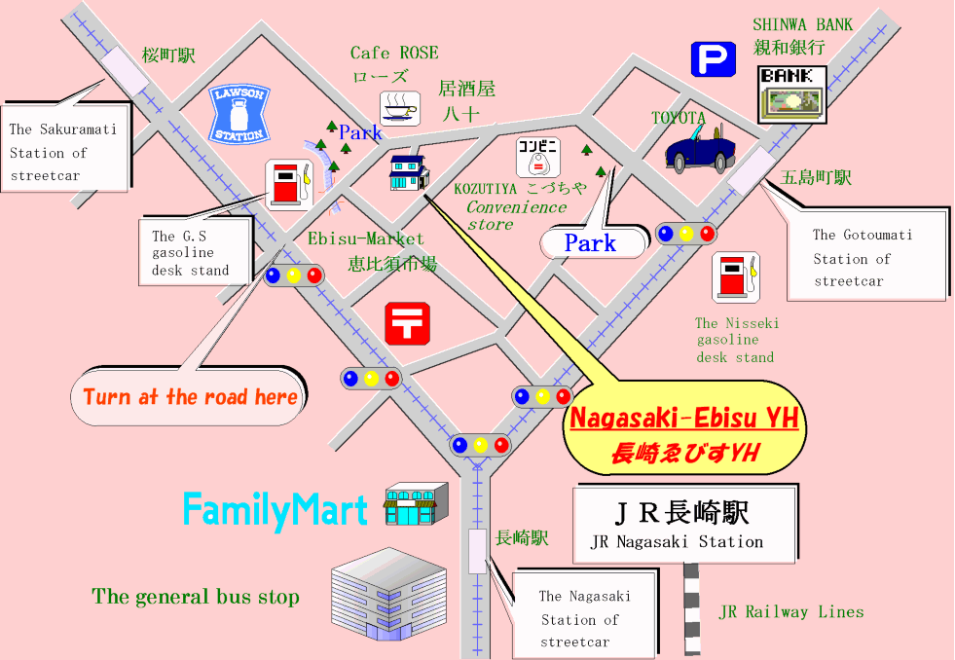

FUKUMATSU RYOKAN
(3500 yens)
Proche de la gare mais que quelques chambres

MINSHUKU FUMI
(3500 yens)

VISITES NAGASAKI
Urakami, point zéro de la déflagration
Parc du point zéro
Musée de la bombe atomtique de Nagasaki (200 yens) 8h30-17h
Heiwa-koen (parc de la paix) avec statue de la paix
Cathédrale d’Urakami
Quartier de la gare
Teramachi (allée des temples)
Panorama d’Inasa-yama : funiculaire (1200 yens AR) 9h-21h toutes les 20 min
333 m, vue superbe sur Nagasaki

MARDI 18 SEPTEMBRE 火曜日9月18日

TRAJET NAGASAKI – KUMAMOTO (215 kms)

NAGASAKI | TOSU |  | KUMAMOTO
8h30 | 9h59 |  |  | LTD.EXP KAMOME 8
 |  | 10h12 | 11h16 | LTD.EXP ARIAKE 1
 |  | 10h31 | 11h25 | LTD.EXP RELAY TSUBAME 7
 |  | 10h36 | 11h48 | LTD.EXP HAYABUSA
8h50 | 10h37 |  |  | LTD.EXP KAMOME 10
 |  | 10h52 | 11h52 | LTD.EXP RELAY TSUBAME 41
9h30 | 10h59 |  |  | LTD.EXP KAMOME 12
 |  | 11h13 | 12h17 | LTD.EXP ARIAKE 3
 |  | 11h30 | 12h24 | LTD.EXP RELAY TSUBAME 9
10h | 11h37 |  |  | LTD.EXP KAMOME 14
 |  | 11h51 | 12h51 | LTD.EXP RELAY TSUBAME 43

NAGASAKI Leave - TOSU Arrive (18/09/2007)
Train name | NAGASAKI | URAKAMI | ISAHAYA | HIZENKASHIMA | HIZENYAMAGUCHI | SAGA | TOSU
LTD.EXP KAMOME 8 | 08:30 | 08:33 | 08:48 | 09:23 | 09:35 | 09:45 | 09:59
LTD.EXP KAMOME 10 | 08:50 | 08:53 | 09:10 | 09:57 | 10:12 | 10:23 | 10:37
LTD.EXP KAMOME 12 | 09:30 | 09:34 | 09:49 | 10:25 | 10:35 | 10:45 | 10:59
LTD.EXP KAMOME 14 | 10:00 | 10:03 | 10:18 | 10:57 | 11:12 | 11:22 | 11:37
LTD.EXP KAMOME 16 | 10:30 | 10:33 | 10:48 | 11:25 | 11:35 | 11:45 | 11:59

TOSU Leave - KUMAMOTO Arrive (18/092007)
Train name | TOSU | KURUME | HAINUZUKA | SETAKA | OMUTA | TAMANA | KAMIKUMAMOTO | KUMAMOTO
LTD.EXP ARIAKE 1 | 10:12 | 10:17 | 10:26 | 10:30 | 10:40 | 10:57 | 11:12 | 11:16
LTD.EXP RELAY TSUBAME 7 | 10:31 | 10:36 | -> | -> | 10:56 | -> | -> | 11:25
*LTD.EXP HAYABUSA | 10:36 | 10:45 | -> | -> | 11:10 | -> | -> | 11:48
LTD.EXP RELAY TSUBAME 41 | 10:52 | 10:57 | 11:06 | 11:10 | 11:20 | 11:32 | 11:48 | 11:52
LTD.EXP ARIAKE 3 | 11:13 | 11:18 | 11:27 | 11:31 | 11:41 | 11:58 | 12:13 | 12:17
LTD.EXP RELAY TSUBAME 9 | 11:30 | 11:36 | -> | -> | 11:56 | -> | -> | 12:24
LTD.EXP RELAY TSUBAME 43 | 11:51 | 11:57 | 12:05 | 12:10 | 12:19 | 12:32 | 12:47 | 12:51
LTD.EXP ARIAKE 5 | 12:13 | 12:19 | 12:27 | 12:32 | 12:41 | 12:56 | 13:12 | 13:15

KUMAMOTO熊本

VISITES KUMAMOTO
(consignes gare de Kumamoto ?)
Château de Kumamoto (500 yens) 8h30-16h30
Vue sur la ville à la pagode (gravir la colline derrière la gare)
TRAJET KUMAMOTO – ASO – BEPPU (160 kms)

KUMAMOTO | ASO | BEPPU
11h36 | 12h44 | 14h38 | LTD.EXP KYUSHU ODAN EXPRESS 4
14h36 | 15h45 | 17h39 | LTD.EXP KYUSHU ODAN EXPRESS 6
17h36 | 18h47 | 20h40 | LTD.EXP KYUSHU ODAN EXPRESS 8

Mt ASO阿蘇山

VISITES ASO
Consigne automatique à la gare d’Aso
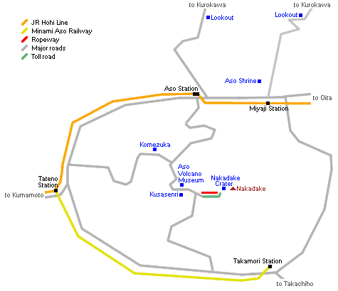
The Nakadake Crater can be reached in a 30-40 minute bus ride from JR Aso Station. There is one bus about every 1-2 hours. The one way trip costs 540 Yen, and is not covered by the Japan Rail Pass.

Cratère de 128 kms de circonférence
Téléphérique pour rejoindre le sommet (1506m) du volcan Nakadake (410 yens – 4 min) / ascension à pied 30 min

Dernier bus part de la station de téléphérique à 17h

BEPPU別府

AUBERGES BEPPU
Se rendre au port pour vérifier si la traversée peut se faire à partir de Beppu ou s’il faut partir de Oita

EKIMAE KOTO ONSEN (1500 à 2500 yens)
Le plus rudimentaire mais près de la gare

BEPPU YOUTH HOSTEL (3000 yens)
Plus sympa, source chaude dans l’auberge mais à 15 min de la gare à pied

BUSINESS HOTEL KAGETSU (3500 yens)
Près de la gare

MERCREDI 19 SEPTEMBRE 水曜日9月19日

Trajets Beppu – Matsuyama FERRY

BEPPU Leave - OITA Arrive (19/09/2007)
Train name | BEPPU | HIGASHIBEPPU | NISHIOITA | OITA
JR Nippo Line | 06:06 | 06:09 | 06:17 | 06:20
JR Nippo Line | 06:49 | 06:52 | 07:00 | 07:03
JR Nippo Line | 07:06 | 07:10 | 07:17 | 07:21
JR Nippo Line | 07:23 | 07:26 | 07:35 | 07:38
JR Nippo Line | 07:32 | 07:35 | 07:42 | 07:46
JR Nippo Line | 07:47 | 07:50 | 07:58 | 08:01
Normalement, s’arrêter une station avant Oita, c’est à dire à Nishioita

OITA大分市

Diamond Ferry
Rising
Flight name | 1 flights | 2 flights
Oita departure  ↓  Matsuyama arrival  Matsuyama departure  ↓  Imabari arrival  Imabari departure  ↓  Kobe arrival | 07:50  ↓  11:20  11:50  ↓  13:30  14:10  ↓  21:10 | 16:20  ↓  20:05  20:35  ↓  22:15  22:40  ↓  05:30

Tarif le moins cher pour la traversée : 3200 yens (2等)
Possible de prendre plus cher pour avoir un lit et terminer la nuit
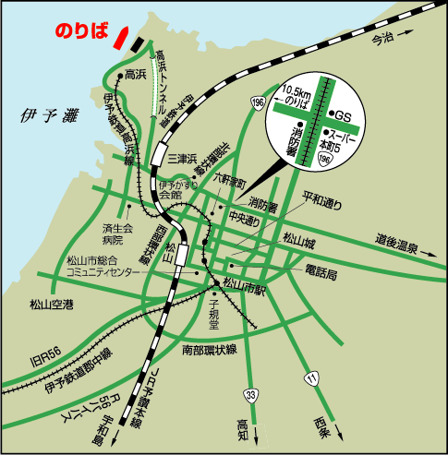 | Pour rejoindre le centre de Matsuyama, prendre la ligne privée Iyo-tetsudo à Takahama jusqu’à Matsuyama City ou Otemachi (environ 400 yens). Départ tous les 15 à 30 minutes.

Trajets OITA – KYOTO TRAIN (727 kms)
Alternative train

OITA | KOKURA |  | OKAYAMA |  | KYOTO
7h15 | 8h43 |  |  |  |  | LTD.EXP SONIC 6
 |  | 8h57 | 12h15 |  |  | SHINKANSEN KODAMA 640
 |  | 9h02 | 10h33 |  |  | SHINKANSEN HIKARI RailStar 450
 |  | 9h16 | 10h51 |  |  | SHINKANSEN HIKARI RailStar 452
7h45 | 9h16 |  |  |  |  | LTD.EXP SONIC 8
8h12 | 9h37 |  |  |  |  | LTD.EXP SONIC 10
 |  | 9h48 | 11h28 |  |  | SHINKANSEN HIKARI RailStar 454
 |  |  |  | 11h33 | 12h58 | SHINKANSEN HIKARI 372
 |  | 10h02 | 13h14 |  |  | SHINKANSEN KODAMA 644
8h40 | 10h05 |  |  |  |  | LTD.EXP SONIC 12
 |  | 10h17 | 11h51 |  |  | SHINKANSEN HIKARI RailStar 456
 |  |  |  | 12h33 | 13h58 | SHINKANSEN HIKARI 374
 |  |  |  | 13h33 | 14h58 | SHINKANSEN HIKARI 376
9h14 | 10h31 |  |  |  |  | LTD.EXP SONIC 14
 |  | 10h55 | 13h55 |  |  | SHINKANSEN KODAMA 646
9h39 | 11h10 |  |  |  |  | LTD.EXP SONIC 16
 |  | 11h17 | 12h51 |  |  | SHINKANSEN HIKARI RailStar 458
 |  |  |  | 13h33 | 14h58 | SHINKANSEN HIKARI 376
 |  | 12h05 | 15h14 |  |  | SHINKANSEN KODAMA 650
 |  | 12h17 | 13h51 |  |  | SHINKANSEN HIKARI RailStar 460
 |  |  |  | 14h33 | 15h58 | SHINKANSEN HIKARI 378
 |  |  |  | 15h33 | 16h58 | SHINKANSEN HIKARI 380

OITA Leave - KOKURA Arrive (19/09/2007)
Train name | OITA | BEPPU | KITSUKI | USA | YANAGIGAURA | NAKATSU | UNOSHIMA | YUKUHASHI | KOKURA
LTD.EXP SONIC 6 | 07:15 | 07:23 | 07:39 | 07:54 | 07:59 | 08:09 | 08:15 | 08:27 | 08:43
LTD.EXP SONIC 8 | 07:45 | 07:53 | 08:10 | 08:25 | 08:30 | 08:42 | 08:48 | 09:01 | 09:16
LTD.EXP SONIC 10 | 08:12 | 08:20 | 08:34 | 08:49 | 08:54 | 09:04 | 09:10 | 09:22 | 09:37
*LTD.EXP SONIC 12 | 08:40 | 08:48 | 09:02 | 09:16 | 09:22 | 09:32 | 09:37 | 09:49 | 10:05
LTD.EXP SONIC 14 | 09:14 | 09:22 | -> | -> | -> | 10:01 | -> | 10:17 | 10:31
LTD.EXP SONIC 16 | 09:39 | 09:48 | 10:06 | 10:21 | 10:27 | 10:38 | 10:43 | 10:55 | 11:10
LTD.EXP SONIC 18 | 10:13 | 10:22 | -> | -> | -> | 11:02 | -> | 11:17 | 11:32
LTD.EXP SONIC 20 | 10:42 | 10:50 | 11:04 | 11:18 | 11:24 | 11:34 | 11:39 | 11:51 | 12:05
LTD.EXP SONIC 22 | 11:14 | 11:23 | -> | -> | -> | 12:02 | -> | 12:17 | 12:32
LTD.EXP SONIC 24 | 11:42 | 11:51 | 12:07 | 12:22 | 12:27 | 12:37 | 12:42 | 12:54 | 13:10
LTD.EXP SONIC 26 | 12:14 | 12:23 | -> | -> | -> | 13:01 | -> | 13:17 | 13:32
LTD.EXP SONIC 28 | 12:40 | 12:49 | 13:02 | 13:17 | 13:22 | 13:33 | 13:38 | 13:50 | 14:05
LTD.EXP SONIC 30 | 13:14 | 13:23 | -> | -> | -> | 14:02 | -> | 14:17 | 14:32
LTD.EXP SONIC 32 | 13:40 | 13:48 | 14:03 | 14:18 | 14:23 | 14:34 | 14:40 | 14:52 | 15:10
LTD.EXP SONIC 34 | 14:14 | 14:23 | -> | -> | -> | 15:02 | -> | 15:17 | 15:32

KOKURA Leave - SHINKOBE Arrive (19/09/2007)
Train name | KOKURA | TOKUYAMA | HIROSHIMA | FUKUYAMA | OKAYAMA | HIMEJI | SHINKOBE
SHINKANSEN HIKARI RailStar 450 | 09:02 | -> | 09:51 | 10:16 | 10:34 | -> | 11:06
SHINKANSEN HIKARI RailStar 452 | 09:16 | 09:45 | 10:10 | 10:35 | 10:52 | 11:14 | 11:30
SHINKANSEN HIKARI RailStar 454 | 09:48 | 10:23 | 10:46 | 11:11 | 11:29 | 11:50 | 12:06
SHINKANSEN HIKARI RailStar 456 | 10:17 | -> | 11:10 | 11:35 | 11:52 | 12:14 | 12:30
SHINKANSEN HIKARI RailStar 458 | 11:17 | 11:46 | 12:10 | 12:35 | 12:52 | 13:14 | 13:30
SHINKANSEN HIKARI RailStar 460 | 12:17 | -> | 13:10 | 13:35 | 13:52 | 14:14 | 14:30
SHINKANSEN HIKARI RailStar 462 | 13:17 | 13:45 | 14:10 | 14:35 | 14:52 | 15:14 | 15:30
SHINKANSEN HIKARI RailStar 464 | 14:17 | -> | 15:10 | 15:35 | 15:52 | 16:14 | 16:30
SHINKANSEN KODAMA 658 | 14:39 | 15:40 | 16:15 | 17:18 | 17:46 | 18:25 | 18:48
SHINKANSEN HIKARI RailStar 466 | 14:52 | 15:22 | 15:46 | 16:11 | 16:28 | 16:50 | 17:06
SHINKANSEN HIKARI RailStar 468 | 15:17 | -> | 16:10 | 16:35 | 16:52 | 17:14 | 17:30
SHINKANSEN KODAMA 662 | 15:44 | 16:40 | 17:23 | 18:18 | 18:46 | 19:25 | 19:48

SHINKOBE Leave - KYOTO Arrive (19/09/2007)
Train name | SHINKOBE | SHINOSAKA | KYOTO
SHINKANSEN HIKARI 370 | 11:25 | 11:43 | 11:58
SHINKANSEN HIKARI 372 | 12:25 | 12:43 | 12:58
SHINKANSEN HIKARI 374 | 13:25 | 13:43 | 13:58
SHINKANSEN HIKARI 376 | 14:25 | 14:43 | 14:58
SHINKANSEN HIKARI 378 | 15:25 | 15:43 | 15:58
SHINKANSEN HIKARI 380 | 16:25 | 16:43 | 16:58
SHINKANSEN HIKARI 382 | 17:25 | 17:43 | 17:58
SHINKANSEN HIKARI 384 | 18:25 | 18:43 | 18:58
SHINKANSEN HIKARI 386 | 19:25 | 19:43 | 19:58
SHINKANSEN HIKARI 390 | 21:19 | 21:33 | 21:48

Possibilités également via Okayama depuis Kokura

MATSUYAMA松山

Visites Matsuyama

Laisser les sacs à la consigne de la gare JR de Matsuyama

Visite du château
Location: 1 Marunouchi, Matsuyama-city
Open : daily 9:00 am-5:00 pm (tickets on sale until 4:30 pm) but varies depending on the season
Admission to the castle tower: 500yen
Time required: Approximately 1 hour
Access: Get off at Okaido, 5-minute walk
Promenade dans les jardins derrière le château (100 yens)

Dogo Onsen
Quartier à 2 kms du centre accessible en tram
Bains du vénérable Dogo Onsen Onkan : 300 yens pour un simple bain, 620 yens pour un bain suivi d’un thé + encas avec location de yukata.

Trajets Matsuyama – Okayama – Kyoto (434 kms)

MATSUYAMA | OKAYAMA |  | KYOTO
12h13 | 14h58 |  |  | LTD.EXP SHIOKAZE 18
 |  | 15h33 | 16h58 | SHINKANSEN HIKARI 380
13h17 | 15h57 |  |  | LTD.EXP SHIOKAZE 20
 |  | 16h33 | 17h58 | SHINKANSEN HIKARI 382
14h16 | 16h57 |  |  | LTD.EXP SHIOKAZE 22
 |  | 17h33 | 18h58 | SHINKANSEN HIKARI 384
15h18 | 17h57 |  |  | LTD.EXP SHIOKAZE 24
 |  | 18h33 | 19h58 | SHINKANSEN HIKARI 386
16h22 | 18h57 |  |  | LTD.EXP SHIOKAZE 26
17h25 | 19h57 |  |  | LTD.EXP SHIOKAZE 28
 |  | 20h38 | 21h48 | SHINKANSEN HIKARI 390

MATSUYAMA Leave - OKAYAMA Arrive (19/09/2007)
Train name | MATSUYAMA | IMABARI | IYOSAIJO | NIIHAMA | KANONJI | TADOTSU | UTAZU | KOJIMA | OKAYAMA
LTD.EXP SHIOKAZE 18 | 12:13 | 12:50 | 13:17 | 13:25 | 14:00 | 14:15 | 14:24 | 14:37 | 14:58
LTD.EXP SHIOKAZE 20 | 13:17 | 13:56 | 14:17 | 14:25 | 14:57 | 15:12 | 15:21 | 15:36 | 15:57
*LTD.EXP SHIOKAZE 22 | 14:16 | 14:53 | 15:15 | 15:23 | 15:57 | 16:13 | 16:23 | 16:36 | 16:57
LTD.EXP SHIOKAZE 24 | 15:18 | 15:55 | 16:17 | 16:25 | 16:58 | 17:14 | 17:22 | 17:36 | 17:57
LTD.EXP SHIOKAZE 26 | 16:22 | 16:57 | 17:17 | 17:25 | 17:58 | 18:14 | 18:22 | 18:36 | 18:57
LTD.EXP SHIOKAZE 28 | 17:25 | 18:01 | 18:21 | 18:29 | 19:01 | 19:16 | 19:25 | 19:38 | 19:57
LTD.EXP SHIOKAZE 30 | 18:44 | 19:22 | 19:45 | 19:52 | 20:24 | 20:43 | 20:52 | 21:05 | 21:27

OKAYAMA Leave - KYOTO Arrive (19/09/2007)
Train name | OKAYAMA | AIOI | HIMEJI | NISHIAKASHI | SHINKOBE | SHINOSAKA | KYOTO
SHINKANSEN HIKARI 380 | 15:33 | 15:50 | 16:02 | 16:14 | 16:25 | 16:43 | 16:58
SHINKANSEN HIKARI 382 | 16:33 | 16:50 | 17:02 | 17:14 | 17:25 | 17:43 | 17:58
SHINKANSEN HIKARI 384 | 17:33 | 17:50 | 18:02 | 18:14 | 18:25 | 18:43 | 18:58
SHINKANSEN HIKARI 386 | 18:33 | 18:50 | 19:02 | 19:14 | 19:25 | 19:43 | 19:58
SHINKANSEN HIKARI 390 | 20:38 | -> | 21:01 | -> | 21:19 | 21:33 | 21:48

KYOTO京都

AUBERGE DE JEUNESSE
Pour les visites à Kyoto et les déplacements prévus en train autour de la ville, il est préférable de choisir une auberge près de la gare.

TOUR CLUB (p321)
www.kyotojp.com
(2415 yens)
Meilleur choix dans la gamme de prix

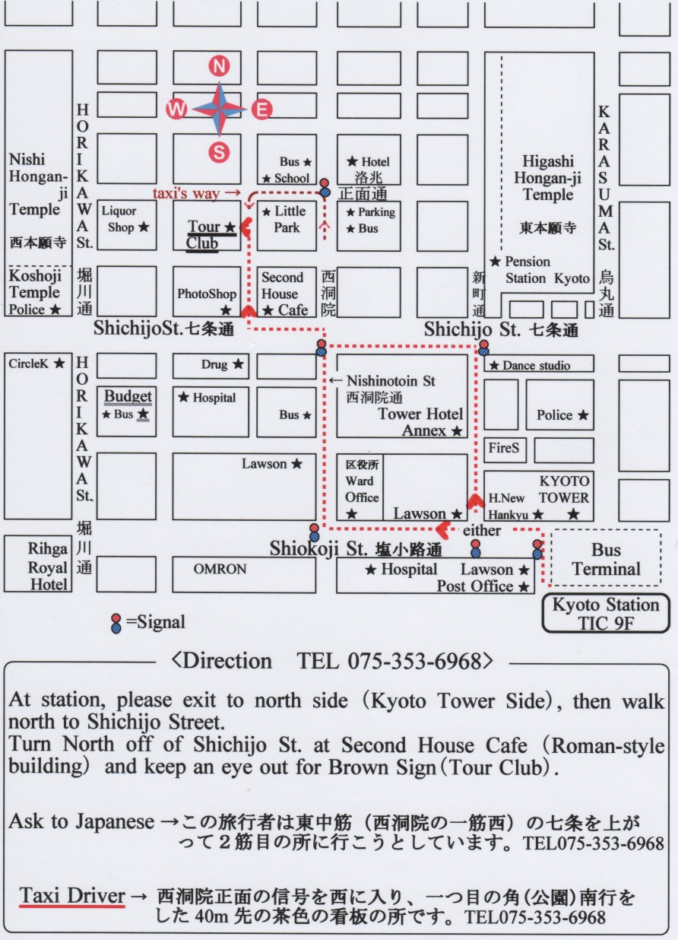

BUDGET INN
(2500 yens)

RIVERSIDE TAKASE
(3900 yens)
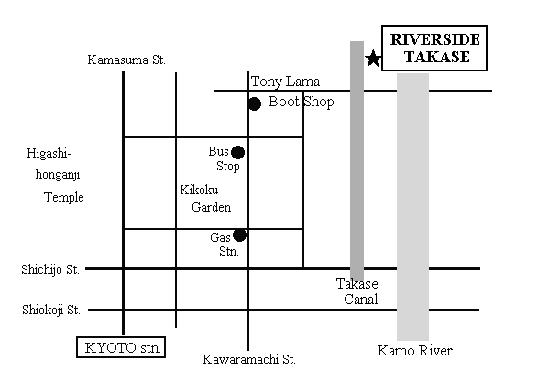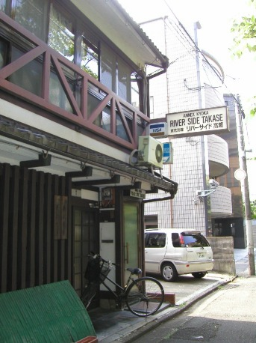
Réserver l’auberge pour 4 nuits
Réserver les billets de Shinkansen pour le lendemain

JEUDI 20 SEPTEMBRE 木曜日9月20日

Visites Kyoto
Cf visites LP p 301

La visite peut-être séparée en plusieurs parties :
- Autour de la gare de Kyoto
  - Temple Nishi Hongan-Ji (gratuit – 5h30/17h30)
  - Gare de Kyoto (vue panoramique depuis le 15ème étage – promenade aérienne au 11ème étage)
  - Jardin Shosei-en (gratuit – 9h/15h30)
- Centre de Kyoto
  - Marché de Nishiki (meilleur marché 9h/17h)
  - Ponto-cho (quartier des geishas, possible de les voir les soirs de week-ends)
- Sud-est de Kyoto
  - Temple Nansen-ji (1000 yens – 8h40/17h)
  - Temple Chion-in (400 yens – 9h/16h)
  - Jardins de Mauyama-koen
  - Chemin des philisophes
  - Temple Kiyomisu-Dera (300 yens – 6/18h)
  - Ballade à suivre dans le NG p 216)
- Sud-Ouest de Kyoto
  - Château Nijo-jo (800 yens – 8h45/16h)
  - Jardins Shinsen-en (gratuit)
- Nord-est de Kyoto
  - Temple Ginkaku-ji (500 yens – 8h30/17h)
  - Temple Honen-in
- Nord-Ouest de Kyoto
  - Kinkaku-ji (pavillon d’or – 400 yens – 9h/17h)

Visite du Kinkaku-ji (le pavillon d’or) un des bâtiments du Rokuonji (temple impérial du jardin des cerfs)

Ryoan-ji Très connu du monde entier, car sa principale attraction étant son jardin zen (jardin de pierre)

VENDREDI 21 SEPTEMBRE 金曜日9月21日
HIMEJI姫路
Trajets Kyoto - Himeji
KYOTO | HIMEJI
8h22 | 9h10 | SHINKANSEN HIKARI 393
8h52 | 10h21 | LTD.EXP SUPER HAKUTO 3
9h21 | 10h16 | SHINKANSEN HIKARI 361
10h21 | 11h16 | SHINKANSEN HIKARI 363
10h55 | 12h19 | LTD.EXP SUPER HAKUTO 5
11h21 | 12h16 | SHINKANSEN HIKARI 365

KYOTO Leave - HIMEJI Arrive (21/09/2007)
Train name | KYOTO | SHINOSAKA | SHINKOBE | NISHIAKASHI | HIMEJI
SHINKANSEN HIKARI 393 | 08:22 | 08:38 | 08:52 | -> | 09:10
LTD.EXP SUPER HAKUTO 3 | 08:52 | 09:16 | -> | -> | 10:21
SHINKANSEN HIKARI 361 | 09:21 | 09:38 | 09:53 | 10:03 | 10:16
SHINKANSEN HIKARI 363 | 10:21 | 10:38 | 10:53 | 11:03 | 11:16
LTD.EXP SUPER HAKUTO 5 | 10:51 | 11:17 | -> | -> | 12:19
SHINKANSEN HIKARI 365 | 11:21 | 11:38 | 11:53 | 12:03 | 12:16

Visites Himeji  Château d’Himeji (600 yens – 9h/17h)  Koko-en (300 yens – 9h/16h30) Reconstruction du quartier général des samourais  Acheter les 2 billets en même temps (en achetant le koko-ken) pour économiser 180 yens | Trajets Himeji - Kyoto
  HIMEJI | KYOTO
  12h02 | 12h58 | SHINKANSEN HIKARI 372
  13h02 | 13h58 | SHINKANSEN HIKARI 374
  14h02 | 14h58 | SHINKANSEN HIKARI 376
  14h55 | 16h24 | LTD.EXP SUPER HAKUTO 8
  15h02 | 15h58 | SHINKANSEN HIKARI 378
  16h02 | 16h58 | SHINKANSEN HIKARI 380

HIMEJI Leave - KYOTO Arrive (21/09/2007)
Train name | HIMEJI | NISHIAKASHI | SHINKOBE | SHINOSAKA | KYOTO
SHINKANSEN HIKARI 372 | 12:02 | 12:14 | 12:25 | 12:43 | 12:58
LTD.EXP SUPER HAKUTO 6 | 12:55 | -> | -> | 13:59 | 14:24
SHINKANSEN HIKARI 374 | 13:02 | 13:14 | 13:25 | 13:43 | 13:58
SHINKANSEN HIKARI 376 | 14:02 | 14:14 | 14:25 | 14:43 | 14:58
LTD.EXP SUPER HAKUTO 8 | 14:55 | -> | -> | 15:59 | 16:24
SHINKANSEN HIKARI 378 | 15:02 | 15:14 | 15:25 | 15:43 | 15:58
SHINKANSEN HIKARI 380 | 16:02 | 16:14 | 16:25 | 16:43 | 16:58

Visites KYOTO APRES MIDI
SAMEDI 22 SEPTEMBRE 土曜日9月22日

Visites KYOTO MATIN
KOBE神戸

Trajet Kyoto – Kobe

Depuis Kyoto, prendre la JR Kyoto Line ou la JR Special Rapid Service jusqu’à Osaka (train toutes les 5 minutes)
JR special Rapide Service plus rapide (28 min contre 44 min) mais train tous les ¼ d’heures (14h – 14h15 – 14h30 – 14h45…)

Depuis Osaka, prendre la JR Kobe Line ou la JR Special Rapid Service jusqu’à Kobe (sortir à la station Sannomiya (trains toutes les 5 minutes)
Idem pour les horaires de la JR Special Rapid Service

Visites Kobe
Récupérer une carte Kobe City Map à l’un des 2 offices de tourisme

Kobe Harbord Land (à 5 min à pied au sud-est de la gare)
Centres commerciaux et complexes de restauration. Vue magnifique depuis le niveau 18 de l’Ecoll Marine Building (ascenseur de verre gratuit)
Meriken Park
Quartier de Kitano (quartier agréable pour une promenade)
Téléphérique de Shin-Kobe (9h30/20h – 550 yens aller)
Montagne à 400 m au dessus de la ville : baie magnifique surtout au coucher du soleil
Jardin des plantes aromatiques (200 yens) pour redescendre à pied en 30 min
Chinatown (promenade agréable surtout le soir avec les illuminations du quartier)

Port de Kobe et ses autoroutes suspendues

Trajet Kobe – Kyoto
Idem aller en sens inverse
Prendre le train au plus tard à 23h
Dernier départ de Osaka un peu après minuit

DIMANCHE 23 SEPTEMBRE 日曜日9月23日
Laisser les sacs à la consigne de la gare de Kyoto

Trajet Kyoto - Osaka
Idem que pour se rendre à Kobe la veille
OSAKA大阪市
Visites Osaka

Il faut absolument goûter les takoyaki (beignets de poulpe) qu'on mange dans la rue (il y en a de bons à namba) et les okonomiyaki (sorte de crêpe japonaise) : ce sont les spécialités locales.

Nord de la ville (Kita)
Umeda Sky Building
Vue fantastique du haut des tours (plateformes d’observation 700 yens – 10h/22h30)

Kyobashi
(Prendre la JR Kanku Rapid ou la JR Osaka-Loop Line depuis Osaka et descendre à Kyobashi (3ème arrêt))
Panasonic Center (http://panasonic.co.jp/center/osaka/en/)
http://panasonic.co.jp/center/osaka/en/access/

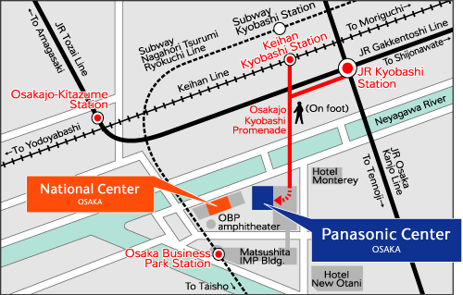

Open : from 10 a.m. to 6 p.m.
Closed : Wednesdays (except holidays), Obon holidays, year end and New Year holidays
Address : 2-1-61 Shiromi, Cho-ku, Osaka 540-6201
Tel : 06-6949-2111
Access : By train
* Seven minutes' walk from the west exit of JR Kyobashi Station
* Seven minutes' walk from the Katamachiguchi exit of Kyobashi Station on Keihan Line
* Five minutes' walk from the first exit of JR Osakajo-Kitazume Station
* Three minutes' walk from the fourth exit of Osaka Business Park Station on Subway
Nagahori Tsurumi Ryokuchi Line

Visite du Château d’Osaka
(se rendre au château à pied depuis Kyobashi)
(600 yens – 9h/17h)

Se rendre à pied à l’île de Nakano-Shima puis prendre le métro pour Minami

Shinsaibashi/Namba
Sony plaza
http://www.asiarooms.com/travel-guide/japan/osaka/things-to-do-in-osaka/shopping-in-osaka/where-to-shop-in-osaka/sony-plaza.html
1-1-10 Shinsaibashi-suji
Osaka, 27 Japan
Open Hours11am-7pm; Sony Plaza is open until 8pm daily

Sony Plaza is a large store which provides imported goods to customers from all over the world.Infact any specialty product which may not be available in most of the nearby shops is usually available here. It also displays the entire range of Sony's latest toys. Sony Plaza, Osaka offers all the cute things to children and young women and it becomes impossible for them to ignore the magnetic pull of this plaza as they pass by it. Sony Plaza, Osaka also provides an enormous collection of imported trendy items like candy, and seasonal decorations. During festivals like Halloween, Xmass etc it is a lot of fun to shop in Sony Plaza, Osaka which is the ultimate shopping destination to find some cute and cheerful gift . Sony Plaza, Osaka is open daily till 8 pm.

Amerika-Mura
Quartier de Dotombori
Galerie couverte de Doguya-Suji

Rejoindre la gare de Shinimamiya en métro

Trajet Osaka - Nara
Prendre la ligne JR Yamatoji jusqu’à la gare de Nara

SHINIMAMIYA Leave - NARA Arrive (23/09/2007)
Train name | SHINIMAMIYA | TENNOJI | HIRANO | KAMI | KYUHOJI | OJI | HORYUJI | YAMATOKOIZUMI | KORIYAMA | NARA
JR Yamatoji Line | 13:36 | 13:38 | -> | -> | 13:44 | 13:56 | 14:00 | 14:03 | 14:06 | 14:11
JR Yamatoji Line | 13:49 | 13:52 | 13:57 | 13:59 | 14:04 | 14:29 | 14:32 | 14:36 | 14:39 | 14:44
JR Yamatoji Line | 13:55 | 13:57 | -> | -> | 14:03 | 14:15 | 14:19 | 14:22 | 14:25 | 14:30
JR Yamatoji Line | 14:09 | 14:12 | 14:17 | 14:19 | 14:24 | 14:49 | 14:53 | 14:56 | 15:00 | 15:05
JR Yamatoji Line | 14:15 | 14:17 | -> | -> | 14:23 | 14:35 | 14:38 | 14:41 | 14:45 | 14:50
JR Yamatoji Line | 14:27 | 14:31 | 14:37 | 14:39 | 14:46 | 15:09 | 15:13 | 15:16 | 15:20 | 15:24
JR Yamatoji Line | 14:36 | 14:38 | -> | -> | 14:44 | 14:56 | 15:00 | 15:03 | 15:06 | 15:11
JR Yamatoji Line | 14:55 | 14:57 | -> | -> | 15:03 | 15:15 | 15:18 | 15:22 | 15:25 | 15:30
JR Yamatoji Line | 15:15 | 15:17 | -> | -> | 15:23 | 15:35 | 15:38 | 15:41 | 15:45 | 15:50
JR Yamatoji Line | 15:36 | 15:38 | -> | -> | 15:44 | 15:56 | 15:59 | 16:03 | 16:06 | 16:11
JR Yamatoji Line | 15:55 | 15:57 | -> | -> | 16:03 | 16:15 | 16:19 | 16:22 | 16:25 | 16:30
NARA奈良
Visites Nara
Temple Todai-ji
Admission: 500 Yen
Hours: Opens 7:30 closes 17:30
Gigantesque statue en bronze du boudha

Parc de Nara (Nara Koen)
Nara Park is just a few steps from the Kintetsu Nara Station. From the JR Nara Station, it is a 5-10 minute walk. 1200 daims.

Trajet Nara – Tokyo (555 kms)
Récupérer les sacs à la consigne de Kyoto

NARA | KYOTO |  | TOKYO
16h09 | 16h56 |  |  | JR Nara Line
 |  | 17h | 19h43 | SHINKANSEN HIKARI 380
 |  | 17h35 | 20h13 | SHINKANSEN HIKARI 422
 |  | 17h39 | 21h23 | SHINKANSEN KODAMA 548
16h24 | 17h41 |  |  | JR Nara Line
16h38 | 17h27 |  |  | JR Nara Line
 |  | 18h | 20h43 | SHINKANSEN HIKARI 382
16h57 | 18h02 |  |  | JR Nara Line
17h07 | 18h11 |  |  | JR Nara Line
17h29 | 18h48 |  |  | JR Nara Line
17h39 | 18h31 |  |  | JR Nara Line
 |  | 18h35 | 21h13 | SHINKANSEN HIKARI 424
 |  | 19h | 21h43 | SHINKANSEN HIKARI 384

NARA Leave - KYOTO Arrive (23/09/2007)
Train name | NARA | NARAYAMA | KIZU | TAMAMIZU | JOYO | UJI | OBAKU | ROKUJIZOU | INARI | TOFUKUJI | KYOTO
JR Nara Line | 15:09 | -> | 15:15 | 15:28 | 15:35 | 15:41 | -> | 15:46 | -> | 15:54 | 15:56
JR Nara Line | 15:26 | 15:30 | 15:33 | 15:43 | 16:00 | 16:13 | 16:18 | 16:23 | 16:34 | 16:37 | 16:39
JR Nara Line | 15:39 | -> | 15:46 | 15:58 | 16:05 | 16:11 | -> | 16:16 | -> | 16:24 | 16:26
JR Nara Line | 15:57 | 16:01 | 16:05 | 16:14 | 16:30 | 16:43 | 16:48 | 16:53 | 17:04 | 17:07 | 17:09
JR Nara Line | 16:09 | -> | 16:15 | 16:28 | 16:35 | 16:41 | -> | 16:46 | -> | 16:54 | 16:56
JR Nara Line | 16:24 | 16:28 | 16:33 | 16:43 | 17:00 | 17:14 | 17:18 | 17:23 | 17:36 | 17:39 | 17:41
JR Nara Line | 16:38 | -> | 16:46 | 16:58 | 17:05 | 17:11 | -> | 17:16 | -> | 17:25 | 17:27
JR Nara Line | 16:57 | 17:01 | 17:05 | 17:14 | 17:30 | 17:38 | 17:42 | 17:47 | 17:57 | 18:00 | 18:02
JR Nara Line | 17:07 | 17:11 | 17:15 | 17:28 | 17:39 | 17:46 | 17:50 | 17:54 | 18:06 | 18:09 | 18:11
JR Nara Line | 17:29 | 17:33 | 17:37 | 17:46 | 18:02 | 18:17 | 18:20 | 18:33 | 18:43 | 18:46 | 18:48
JR Nara Line | 17:39 | -> | 17:48 | 17:57 | 18:06 | 18:14 | -> | 18:20 | -> | 18:29 | 18:31
JR Nara Line | 17:53 | 17:58 | 18:03 | 18:14 | 18:30 | 18:40 | 18:46 | 18:54 | 19:06 | 19:09 | 19:11
JR Nara Line | 18:18 | 18:23 | 18:27 | 18:41 | 19:01 | 19:17 | 19:20 | 19:33 | 19:43 | 19:46 | 19:48
JR Nara Line | 18:39 | -> | 18:47 | 18:57 | 19:06 | 19:14 | -> | 19:20 | -> | 19:29 | 19:31

KYOTO Leave - TOKYO Arrive (23/09/2007)
Train name | KYOTO | NAGOYA | SHIZUOKA | ATAMI | SHINYOKOHAMA | SHINAGAWA | TOKYO
SHINKANSEN HIKARI 380 | 17:00 | 17:58 | -> | -> | 19:27 | -> | 19:43
SHINKANSEN HIKARI 422 | 17:35 | 18:13 | 19:11 | -> | -> | 20:06 | 20:13
SHINKANSEN KODAMA 548 | 17:39 | 18:33 | 19:57 | 20:33 | 21:04 | 21:16 | 21:23
SHINKANSEN HIKARI 382 | 18:00 | 18:58 | -> | -> | 20:27 | -> | 20:43
SHINKANSEN HIKARI 424 | 18:35 | 19:13 | 20:11 | -> | -> | 21:06 | 21:13
SHINKANSEN KODAMA 550 | 18:39 | 19:33 | 20:57 | 21:33 | 22:04 | 22:16 | 22:23
SHINKANSEN HIKARI 384 | 19:00 | 19:58 | -> | -> | 21:27 | -> | 21:43
SHINKANSEN HIKARI 426 | 19:35 | 20:13 | 21:11 | -> | -> | 22:06 | 22:13
LUNDI 24 SEPTEMBRE 月曜日9月24日

TOKYO 東京

VISITE DE TOKYO
Sunshine 60 dans le quartier d’Ikebukuro (véritable ville dans un gratte-ciel (Parc à thème NAMCO, Aquarium, vue panoramique sur Tokyo à 240m, ascenseur ultra-rapide,…)

Situé dans la baie de Tokyo, Odaiba permet d'avoir une vue d'ensemble de Tokyo et de son Rainbow Bridge (ligne Yurikamone recemment rénovée, au départ de Shinbashi, qui traverse la baie sur le Rainbow Bridge)

REPAS A TOKYO
Surtout présent dans Tokyo et ses environs, Ootoya est une chaîne de restaurants japonais proposant de succulents plats traditionels à base de viandes, volailles ou de poissons.
Les prix sont tout à fait abordables (environ 700-800¥ le plat) et vous disposez d'un grand choix.
Pour finir, l'ambiance est très calme (ce n'est pas un fast-food) et agréable.
Vous trouverez donc des "Ootoya" un peu partout dans Tokyo (Shibuya, Harajuku ...).
Prix: environ 700-800¥ pour un plat

MARDI 25 SEPTEMBRE 火曜日9月25日

Trajet Tokyo – HAKONE

TOKYO Leave - ODAWARA Arrive (25/09/2007)
Train name | TOKYO | SHINAGAWA | SHINYOKOHAMA | ODAWARA
SHINKANSEN KODAMA 565 | 08:23 | 08:30 | 08:45 | 09:02
SHINKANSEN HIKARI 365 | 08:36 | -> | 08:53 | 09:09
SHINKANSEN KODAMA 535 | 08:56 | 09:04 | 09:16 | 09:32
LTD.EXP ODORIKO 105 | 09:00 | 09:07 | -> | 10:01
LTD.EXP ODORIKO 105 | 09:00 | 09:07 | -> | 10:01
SHINKANSEN KODAMA 567 | 09:23 | 09:30 | 09:45 | 10:02
SHINKANSEN KODAMA 537 | 09:56 | 10:04 | 10:16 | 10:32
LTD.EXP ODORIKO 107 | 10:00 | 10:07 | -> | 11:01
SHINKANSEN KODAMA 569 | 10:23 | 10:30 | 10:45 | 11:02
SHINKANSEN HIKARI 369 | 10:36 | -> | 10:53 | 11:09
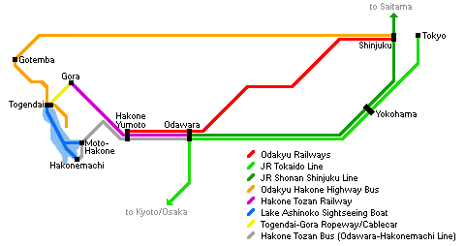
With JR trains you can only get as far as Odawara, from where you will have to use non-JR trains or buses into the Hakone area (see map). Note that the above mentioned Hakone Free Pass is also available for use from Odawara Station.
By JR Tokaido Shinkansen you can access Odawara in about half an hour from Tokyo or Shinagawa Station (about 3500 Yen one way, fully covered by the Japan Rail Pass), but note that only kodama trains and a small number of hikari trains stop at Odawara Station.
Alternatively, you can access Odawara from Tokyo in about 70-90 minutes by local or rapid trains on the JR Tokaido Main Line (stopping at Tokyo, Shimbashi and Shinagawa Stations) or the JR Shonan Shinjuku Line (stopping at Ikebukuro, Shinjuku and Shibuya Stations) for about 1450 Yen (one way).

VISITE HAKONE
HAKONE 箱根
Acheter le pass à la gare d’Odawara (4170 yens)

Hakone Free Pass
1) | One round trip to the Hakone free area by Odakyu Railways. (Not applicable if you buy the pass for usage from a station inside the free area, such as Odawara or Mishima.)
2) | Unlimited use of Odakyu affiliated buses, trains, boats, cablecars and ropeways within the Hakone free area.
3) | Discounted admission to selected tourist attractions.
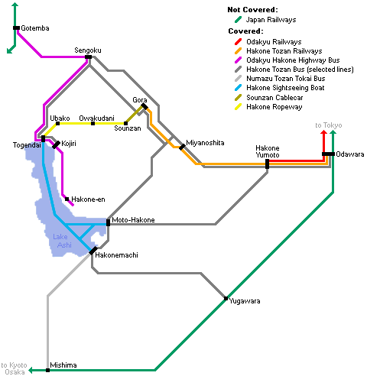
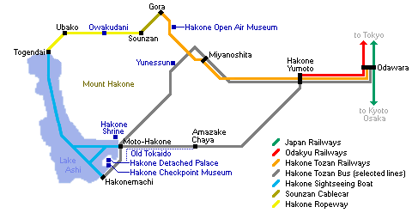

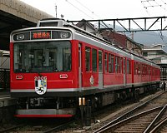 | Hakone-Yumoto to Gora  by Hakone Tozan Railway  35 minutes, departures every 10-15 minutes  The Hakone Tozan Railway winds itself through a narrow, densely wooded valley, gaining more than 300 meters in altitude. Several hot springs and the Hakone Open Air Museum are located along its route.

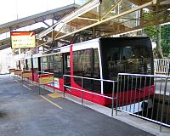 | Gora to Sounzan  by Hakone Tozan Cablecar  10 minutes, departures every 20 minutes  The Hakone Art Museum and Gora Park are located in Gora along the cablecar route.

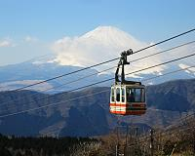 | Sounzan to Togendai  by Hakone Ropeway  30 minutes, constant departures  Nice views of Mount Fuji and the national park can be enjoyed from the ropeway when visibility is good. A transfer of ropeways is required at Owakudani, where travelers can observe volcanic activities.

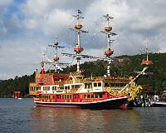 | Togendai to Hakonemachi  by Hakone Sightseeing Boat  30 minutes, departures every 30-60 minutes  Nice views of Lake Ashi, the surrounding wooded mountains and Mount Fuji can be enjoyed from the pirate ship shaped boats when visibility is good. Most ships operate from Togendai to Hakonemachi and then continue to Moto-Hakone.

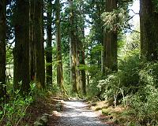 | Hakonemachi to Moto-Hakone  on foot  20-30 minutes  The Checkpoint Museum, Detached Palace Garden and the the Ancient Cedar Avenue are located along this attractive walk from Hakonemachi to Moto-Hakone. Alternatively you could continue to Moto-Hakone by boat or take a bus.

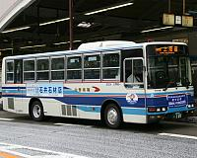 | Moto-Hakone to Hakone-Yumoto  by Hakone Tozan Bus  35 minutes, departures every 15-20 minutes  Visit Hakone Shrine in Moto-Hakone and then return by bus to Yumoto, possibly with a stop at Yunessun along the way. Alternatively, you could walk a section of the Old Tokaido and catch a bus from the Amazake Chaya or Hatajuku back to Yumoto.

Trajet HAKONE – TOKYO
ODAWARA Leave - TOKYO Arrive (25/09/2007)
Train name | ODAWARA | SHINYOKOHAMA | SHINAGAWA | TOKYO
SHINKANSEN HIKARI 372 | 15:09 | 15:27 | -> | 15:43
SHINKANSEN KODAMA 576 | 15:17 | 15:37 | 15:50 | 15:56
SHINKANSEN KODAMA 538 | 15:47 | 16:04 | 16:16 | 16:23
SHINKANSEN KODAMA 578 | 16:17 | 16:37 | 16:50 | 16:56
LTD.EXP ODORIKO 116 | 16:43 | -> | 17:37 | 17:44
LTD.EXP ODORIKO 116 | 16:43 | -> | 17:37 | 17:44
SHINKANSEN KODAMA 540 | 16:47 | 17:04 | 17:16 | 17:23
SHINKANSEN KODAMA 580 | 17:17 | 17:37 | 17:50 | 17:56
SHINKANSEN KODAMA 542 | 17:47 | 18:04 | 18:16 | 18:23
SHINKANSEN HIKARI 378 | 18:09 | 18:27 | -> | 18:43
SHINKANSEN KODAMA 582 | 18:17 | 18:37 | 18:50 | 18:56
SHINKANSEN KODAMA 544 | 18:47 | 19:04 | 19:16 | 19:23

MERCREDI 26 SEPTEMBRE 水曜日9月26日

VISITE TOKYO MATIN

Trajet Tokyo – FUJIYAMA

The bus is called the Fuji Kyuko. The bus station is located in front of the Yodobashi Camera store. Take either the West or South exit from Shinjuku Station (easier said than done) and make your way there. It's best to call ahead for a reservation, but read the details in the paragraph below before you call. Here are two phone numbers (one of them should be for English speakers): 03-5376-2222 and 03-3376-1111.

Bus depuis Shinjuku jusqu’à Kawaguchiko (1700 yens)
Leave  Shinjuku | Arrive  Kawaguchiko
11:10 | 12:55
11:40 | 13:32
12:10 | 13:55
12:40 | 14:32
13:10 | 14:55
14:10 | 15:55
15:10 | 16:55
16:10 | 17:55
17:10 | 18:55
18:10 | 19:55
19:10 | 20:55
20:10 | 21:55

Puis prendre un taxi jusqu’à la station 5 (environ 10 000 yens)
Un bus part de Kawaguchiko pour la station 5 à 12h40

Here's a tip. When you finish hiking Mount Fuji you'll be tired, sweaty and dusty, and you may still have several hours of travel to get home by bus and trains. I suggest you bring a change of clothes, some toiletries and food to tide you over until you get to Shinjuku. Put all of this in one of the many lockers at the 5th Station, and you'll be patting yourself on the back at the end of the day.

Mt FUJI 富士山

ASCENSION FUJIYAMA

JEUDI 27 SEPTEMBRE 木曜日9月27日

Trajet FUJIYAMA – TOKYO

5th Sta. → Kawaguchiko
Leave  5th Sta. | Arrive  Kawaguchiko
● 1130 | 1218
● 1230 | 1318
● 1330 | 1418
△ 1430 | 1518

Puis

Leave  Kawaguchiko | Arrive  Shinjuku
12:59 | 14:44
△13:29 | 15:14
13:59 | 15:44
14:28 | 16:20
14:59 | 16:44
15:20 | 17:12
15:59 | 17:44
△16:29 | 18:14
17:07 | 18:52

Ou direct 5ème station – Shinjuku à 14h → 16h25

VISITE TOKYO fin APREM

VENDREDI 28 SEPTEMBRE 金曜日9月28日

Trajet TOKYO – NARITA

7h30→8h35 (NEX7)
8h→9h02 (NEX9)
8h30→9h27 (NEX11)
9h→9h56 (NEX13)
10h03→10h55 (NEX15)

NARITA 成田

VOL RETOUR

Départ TOKYO NARITA TERMINAL 2 12 :00
Arrivée MOSCOU
AEROFLOT n°SU576 – BOEING 767

Départ MOSCOU
Arrivée PARIS CHARLES DE GAULLE 20 :45
AEROFLOT n°SU576 – AIRBUS A321

COMPLEMENTS

How to use a bus
Using buses in Japan can be intimidating to foreign tourists, because there are usually few English displays and announcements, and there are different systems of using buses depending on the company. Below is a description of the most common system, followed by notes about prominent exceptions:
1) Enter the bus through the back door (or front door if there is only one door).
2) When entering, pick up a ticket from a small machine. A number is printed on the ticket, which you will later use to determine your fare.
3) A display above the driver shows the next stop and the fares for that stop in Yen. To determine your fare, match the number on your ticket with the number and fare on the display.
4) When your stop is approaching, press one of the buttons on the wall to signal the driver that you wish to get off at the next stop.
5) If you do not have the exact fare, use the changing machine to get small coins.
6) When getting off, put your ticket and the exact fare into the box next to the driver.
